* **Name of the Activity**: Methodology of People's Biodiversity Register (PBR) and Awareness Programme on Biodiversity
* **Date of the Activity:** 30.06.2023
* **Speakers:** 
  + Dr. S N Ghosh, Senior Research Officer,
  + Ms. Saswati Roy Reeves, District Co-Ordinator, Nadia,
  + Mr. Shamik Guchhait, PBR Monitoring Assistant, West Bengal Biodiversity Board
* **Number of Participants:**
* **Organizing Department:** Seminar Sub-committee, Chakdaha College in association with West Bengal Biodiversity Board (WBBB)
* **Flyer:**

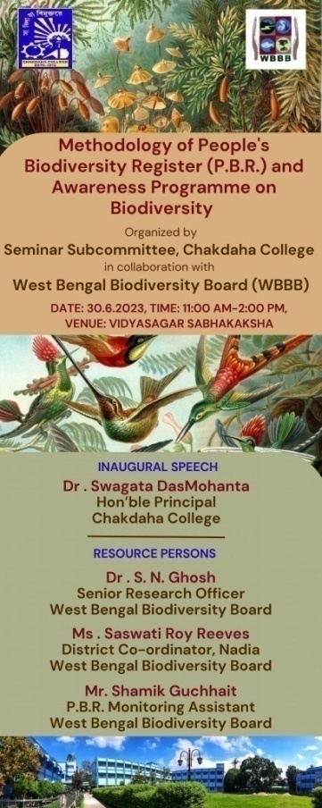

**Some Photographs:**

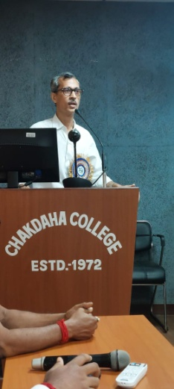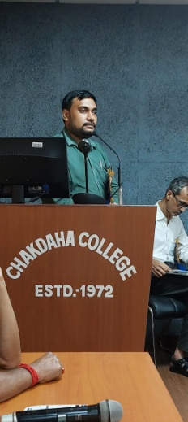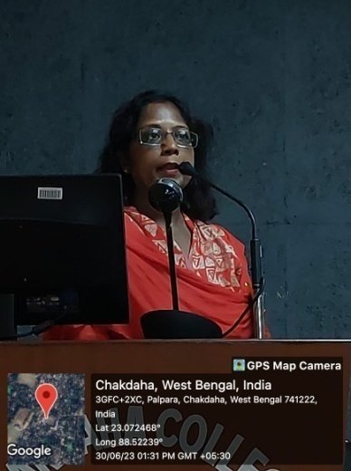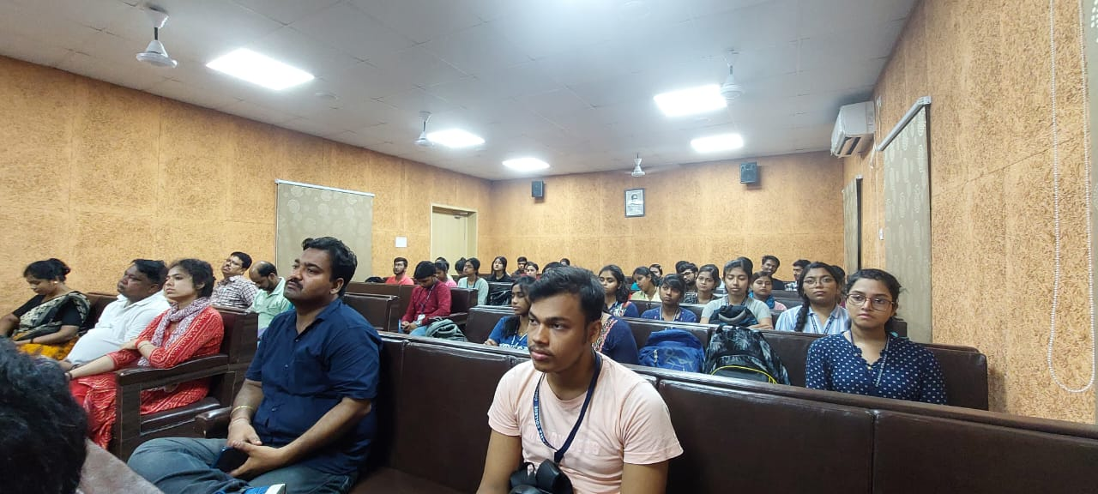

***Relevant Web Link***:

<https://www.facebook.com/photo/?fbid=678226517651449&set=a.447974797343290>